3rd SEM ACHIEVEMENTS:

NPTEL:

INTRODUCTION TO INDUSTRY 4.0 AND INDUSTRIAL INTERNET OF THINGS:
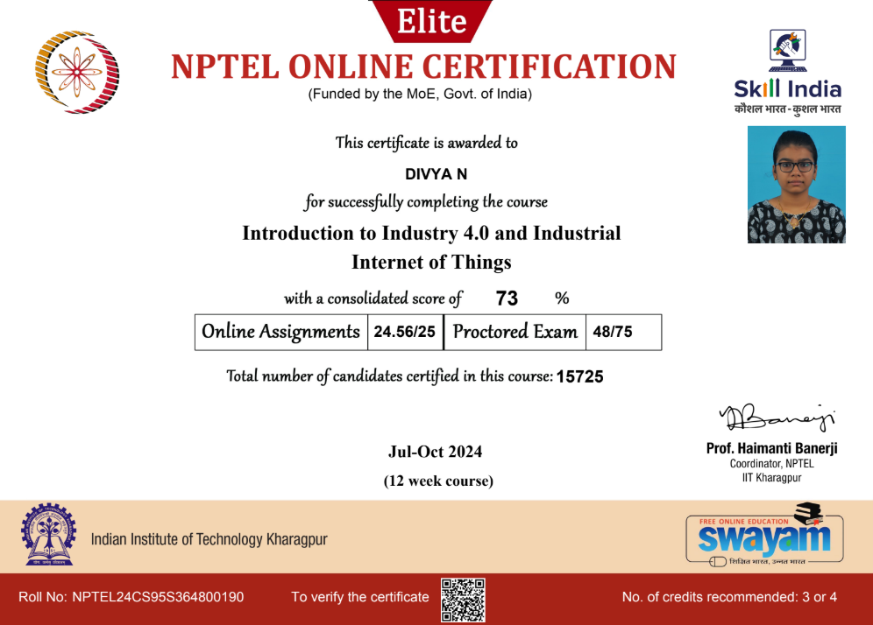

CLOUD COMPUTING:

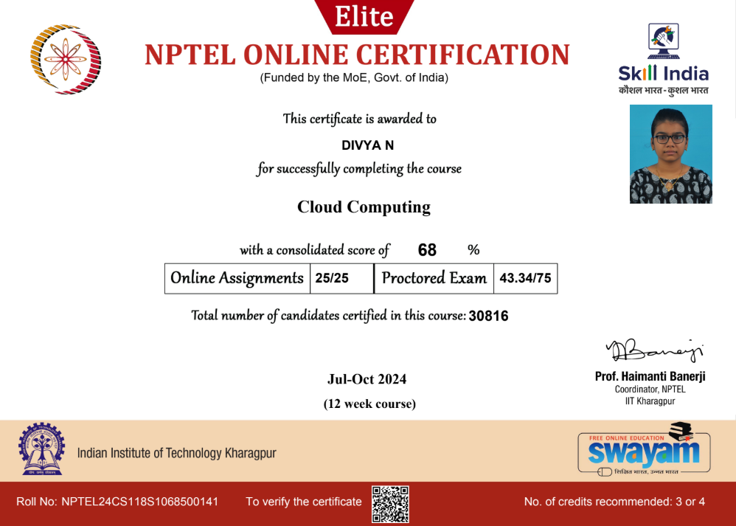

GREAT LEARNING:

- HTML

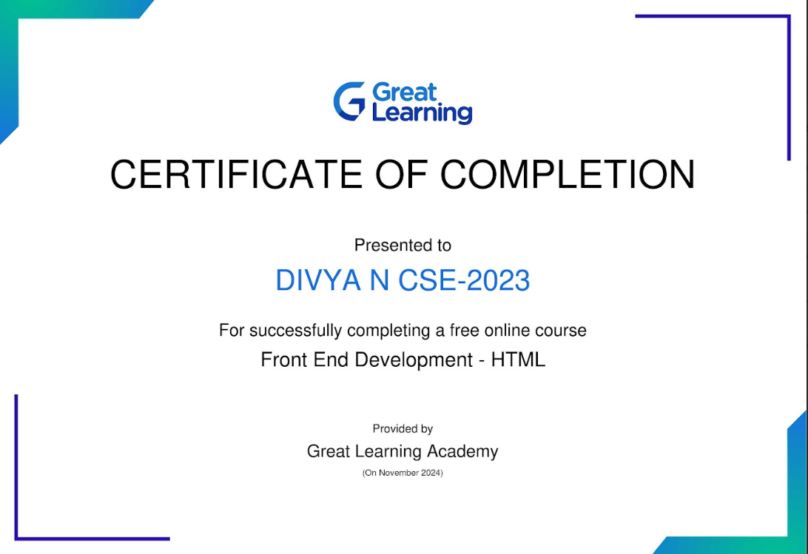

- CSS

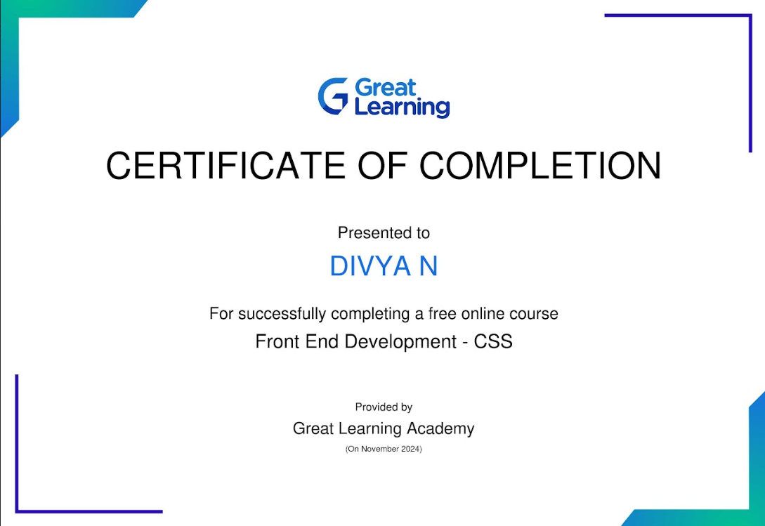

- Generative AI for Beginners:

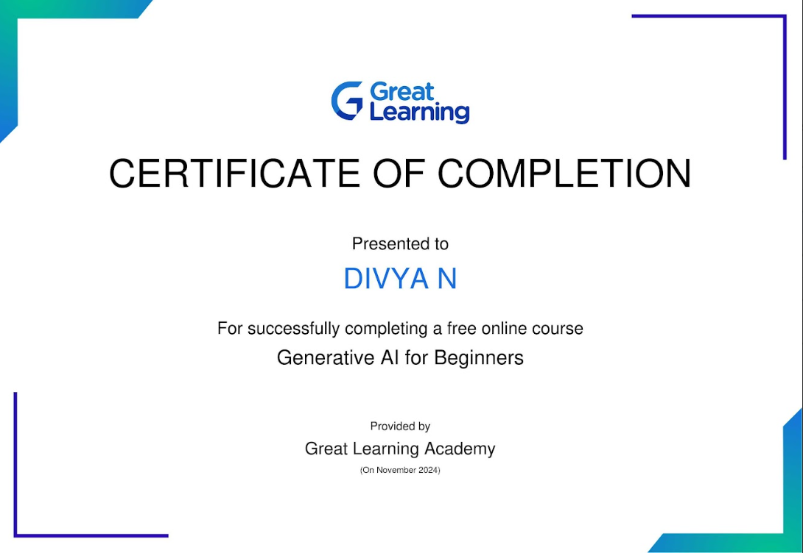

CISCO:

- Network Addressing and Basic Troubleshooting:

